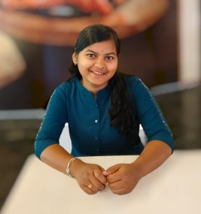

**PRANGYA PARAMITA SAHOO**

<https://www.linkedin.com/in/prangya-paramita-sahoo-817276288>

[sahooprangyapramita@gmail.com](mailto:sahooprangyapramita@gmail.com) | 7008394537

**PROFILE SUMMARY**

Aspiring BCA graduate with a strong enthusiasm for coding and web development, committed to continuous learning and creating impactful digital experiences.

**EDUCATION**

**Bachelor of Computer Applications**

**NARASINGH CHOUDHURY AUTONOMOUS COLLEGE, JAJPUR 2022-2025**

**FUNCTIONAL AREAS**

* Programming Skills
* Web Development

**TECHNICAL SKILLS**

* **Database:** MYSQL
* **Programming Skills:** Java, C, C++, HTML5, CSS3, Javascript
* **Additional Skills:** Operating System

**MY PROJECTS**

**Amazon Website Cloning (Web development) Duration –** 1 Month

* **Designed and developed a responsive Amazon clone website using HTML and CSS.**

**PERSONAL DETAILS**

* Name: Prangya Paramita Sahoo
* Date Of Birth: 05/06/2005
* Gender: Female
* Nationality: Indian
* Language Known: English, Hindi, Odia
* Permanent Address: Jajpur, Odisha, pin- 755005

**DECLARATION**

* I hereby declare that the above information furnished is true to the best of my knowledge and belief.